Midterm Recovery Part One:

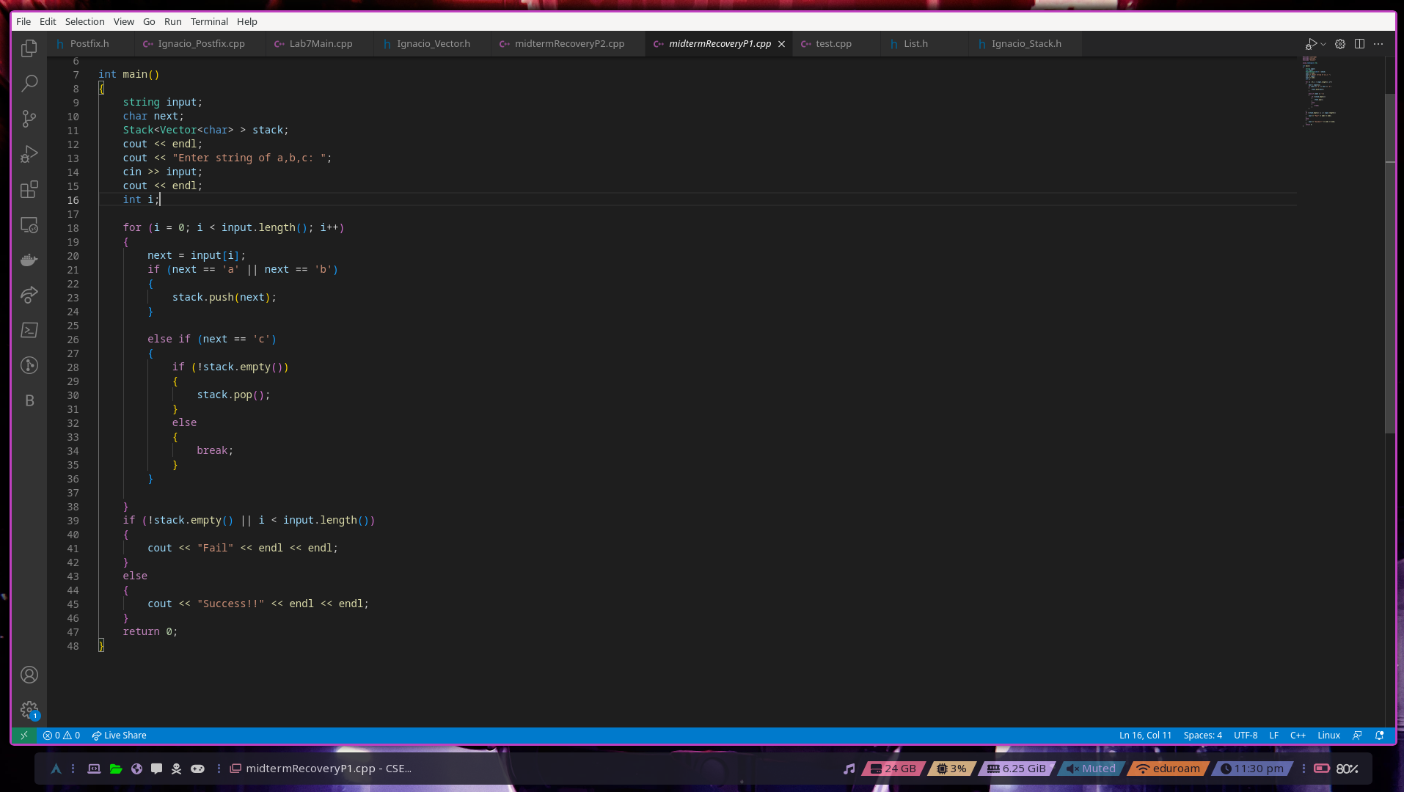

In general this program takes in a list of characters either a,b,c and only pushes a’s or b’s onto the stack. If a c was inputted it checks the stack to see if it is empty and if it isn’t it will pop an a or b off the stack. In order to reach success there has to be a number of c’s that is equal to the numbers of a’s + b’s in a sequence where a c never comes before an a or b if the stack is empty and there are remaining characters in the list of strings. This works with the sequence aabcabcccbbccc. Because it follows the mentioned rules.

Midterm Recovery Part 2:

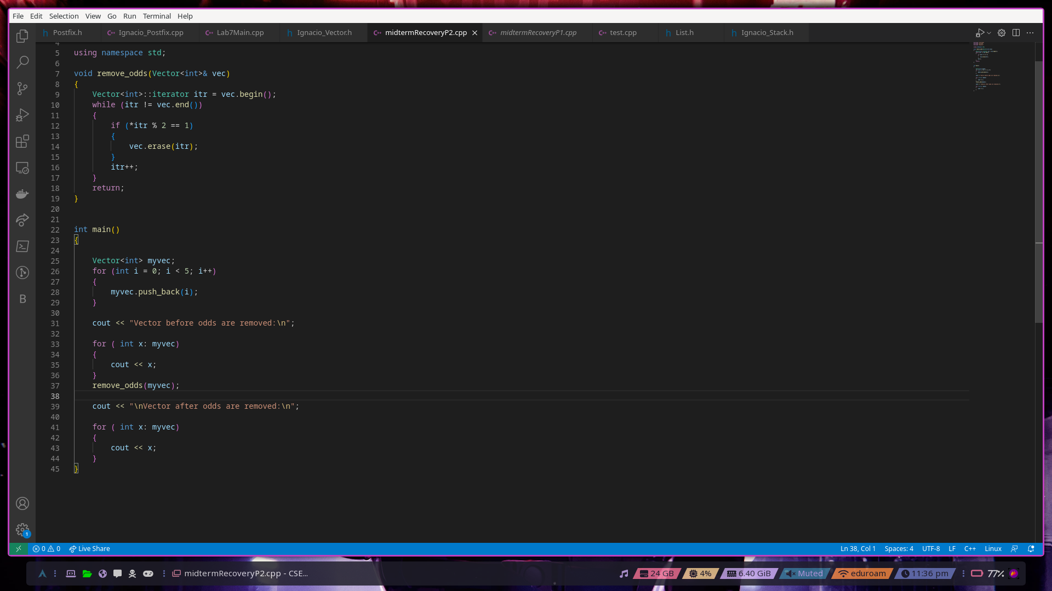

This program will remove all odd integer values only when the last value in the vector that it is passed is even. The reason for this error with having an odd number as the last value is that it tries to increment the iterator itr after erasing an element, which is causing the iterator to point to an invalid memory location.